**INITIAL REQUIREMENTS:** 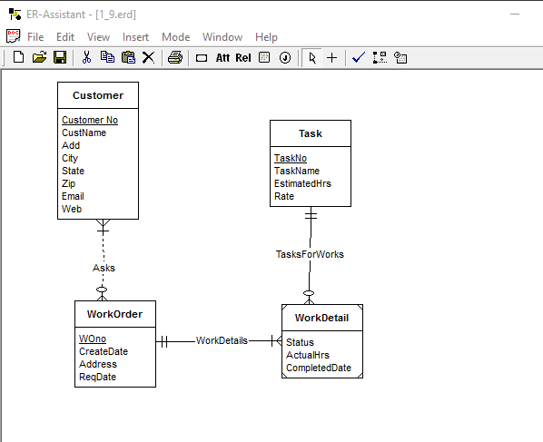

**REVISED REQUIREMENTS:**

